**3. Practice SQL Data Definition Language (DDL) Commands**

**3.1. Table creation and alteration**

**1. Create all 5 tables based on the schema provided.**

**Table Name: Departments**

|  |  |  |
| --- | --- | --- |
| **Column Name** | **Data Type** | **Constraints** |
| Dept_ID | VARCHAR2(4) | PRIMARY KEY, starts with 'D' |
| Dept_Name | VARCHAR2(50) | NOT NULL, UNIQUE |
| Building | VARCHAR2(30) |  |
| Number_of_Classrooms | NUMBER(3) | CHECK(Number_of_Classrooms >= 0) |

**CODE:**

CREATE TABLE Departments (

Dept_ID VARCHAR2(4) PRIMARY KEY CHECK (Dept_ID LIKE 'D%'),

Dept_Name VARCHAR2(50) NOT NULL UNIQUE,

Building VARCHAR2(30),

Number_of_Classrooms NUMBER(3) CHECK (Number_of_Classrooms >= 0) );

**OUTPUT:**

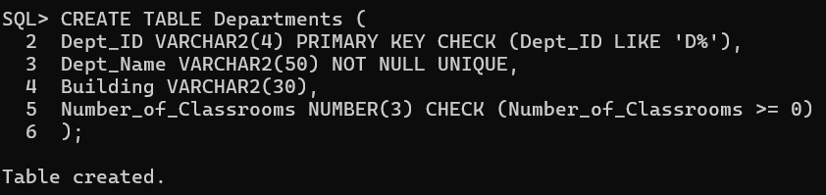

**Table Name: Professors**

|  |  |  |
| --- | --- | --- |
| **Column Name** | **Data Type** | **Constraints** |
| Prof_ID | VARCHAR2(5) | PRIMARY KEY, starts with 'P' |
| Prof_Name | VARCHAR2(50) | NOT NULL |
| Dept_ID | VARCHAR2(4) | FOREIGN KEY REFERENCES Departments(Dept_ID) |
| Experience_Years | NUMBER(2) | CHECK (Experience_Years >= 0) |

**CODE:**

CREATE TABLE Professors

(Prof_ID VARCHAR2(5) PRIMARY KEY CHECK(Prof_ID LIKE 'P%'),

Prof_Name VARCHAR2(50) NOT NULL ,

Dept_ID VARCHAR2(4) REFERENCES Departments(Dept_ID),

Experience_Years NUMBER(2) CHECK(Experience_Years>=0) );

**OUTPUT:**

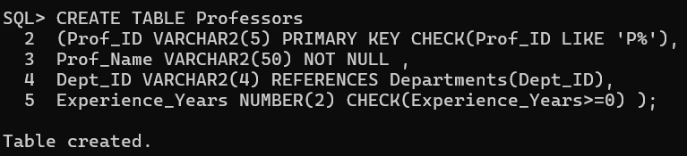

**Table Name: Courses**

|  |  |  |
| --- | --- | --- |
| **Column Name** | **Data Type** | **Constraints** |
| Course_ID | VARCHAR2(6) | PRIMARY KEY |
| Course_Name | VARCHAR2(100) | NOT NULL |
| Dept_ID | VARCHAR2(4) | FOREIGN KEY REFERENCES Departments(Dept_ID) |
| Prof_ID | VARCHAR2(5) | FOREIGN KEY REFERENCES Professors(Prof_ID) |
| Credits | NUMBER(1) | CHECK (Credits BETWEEN 1 AND 5) |
| Student_Count | NUMBER(4) | CHECK (Student_Count >= 0) |

**CODE:**

CREATE TABLE Courses

(Course_ID VARCHAR2(6) PRIMARY KEY ,

Course_Name VARCHAR2(100) NOT NULL ,

Dept_ID VARCHAR2(4) REFERENCES Departments(Dept_ID),

Prof_ID VARCHAR2(5) REFERENCES Professors(Prof_ID),

Credits NUMBER(1) CHECK(Credits BETWEEN 1 AND 5),

Student_Count NUMBER(4) CHECK(Student_Count>=0) );

**OUTPUT:**

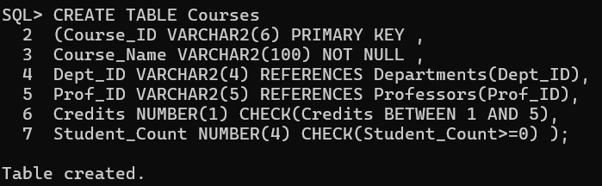

**Table Name: Students**

|  |  |  |
| --- | --- | --- |
| **Column Name** | **Data Type** | **Constraints** |
| Student_ID | VARCHAR2(6) | PRIMARY KEY, starts with 'S' |
| Student_Name | VARCHAR2(50) | NOT NULL |
| Dept_ID | VARCHAR2(4) | FOREIGN KEY REFERENCES Departments(Dept_ID) |
| DOB | DATE |  |

**CODE:**

CREATE TABLE Students

(Student_ID VARCHAR2(6) PRIMARY KEY CHECK(Student_ID LIKE 'S%'),

Student_Name VARCHAR2(50) NOT NULL ,

Dept_ID VARCHAR2(4) REFERENCES Departments(Dept_ID),

DOB DATE );

**OUTPUT:** 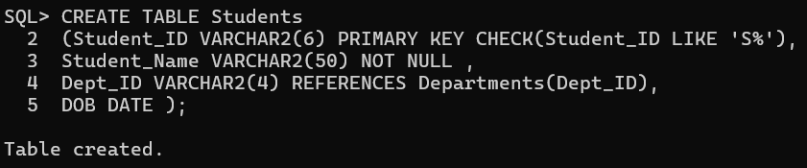

**Table Name: Enrollments**

|  |  |  |
| --- | --- | --- |
| **Column Name** | **Data Type** | **Constraints** |
| Student_ID | VARCHAR2(6) | FOREIGN KEY REFERENCES Students(Student_ID) |
| Course_ID | VARCHAR2(6) | FOREIGN KEY REFERENCES Courses(Course_ID) |
| Semester | VARCHAR2(6) | e.g., 'Sem1', 'Sem2' |
| Marks | NUMBER(5,2) | CHECK (MARKS >= 0 AND MARKS < 100) |
| PRIMARY KEY | (Student_ID, Course_ID) |  |

**CODE:**

CREATE TABLE Enrollments

(Student_ID VARCHAR2(6) REFERENCES Students(Student_ID),

Course_ID VARCHAR2(6)  REFERENCES Courses(Course_ID),

Semester VARCHAR2(6) CHECK(Semester LIKE 'Sem%'),

Marks NUMBER(5,2) CHECK(Marks >= 0 AND Marks < 100),

PRIMARY KEY (Student_ID,Course_ID) );

**OUTPUT:**

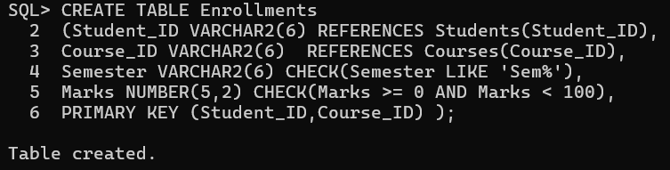

**2. Add a column Dept_Head (varchar2(50)) to Departments.**

**CODE:**

ALTER TABLE Departments

ADD Dept_Head VARCHAR2(50);

**OUTPUT:**

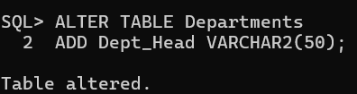

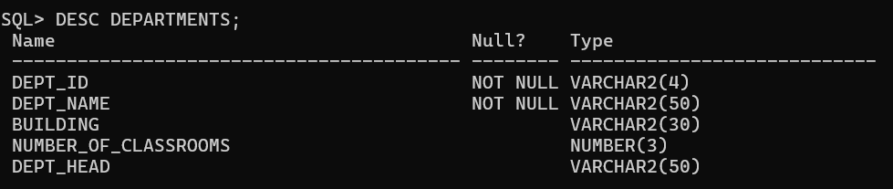

**3. Change size of Experience_Years in Professors to NUMBER(3).**

**CODE:**

ALTER TABLE Professors

MODIFY(Experience_Years NUMBER(3) );

**OUTPUT:**

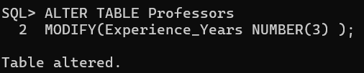

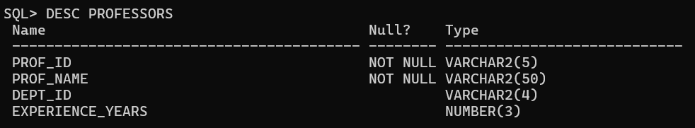

**4. Rename Student_Count to Total_Students in Courses.**

**CODE:**

ALTER TABLE Courses

RENAME COLUMN Student_Count TO Total_Students;

**OUTPUT:**

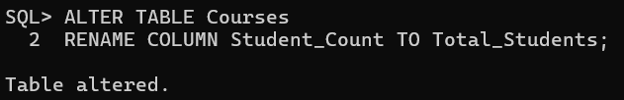

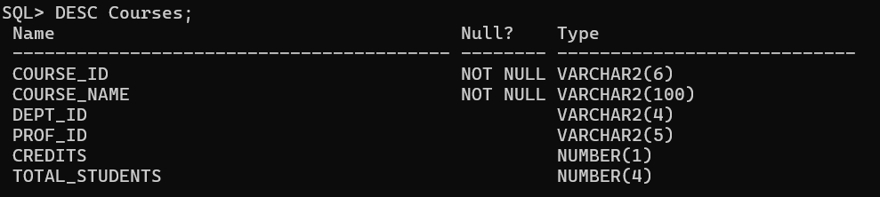

**5. Drop and recreate the Enrollments table.**

**CODE:**

DROP TABLE Enrollments;

CREATE TABLE Enrollments

(Student_ID VARCHAR2(6) REFERENCES Students(Student_ID),

Course_ID VARCHAR2(6)  REFERENCES Courses(Course_ID),

Semester VARCHAR2(6) CHECK(Semester LIKE 'Sem%'),

Marks NUMBER(5,2) CHECK(Marks >= 0 AND Marks < 100),

PRIMARY KEY (Student_ID,Course_ID) );

**OUTPUT:**

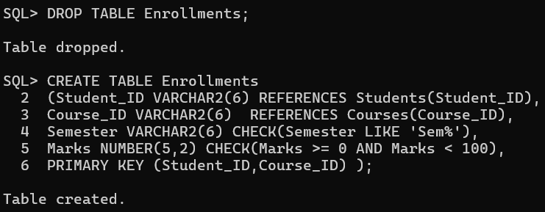

**4. Practice SQL Data Manipulation Language (DML) Commands**

**4.1 Insertion, Deletion, Update**

**1. Insert the sample data into all five tables.**

**Departments:**

|  |  |  |  |
| --- | --- | --- | --- |
| **Dept_ID** | **Dept_Name** | **Building** | **Number_of_Classrooms** |
| D01 | Computer Science | Tech Block | 10 |
| D02 | Electrical Engg. | Power House | 8 |
| D03 | Mechanical Engg. | Mech Block | 6 |

**CODE:**

INSERT INTO Departments VALUES('D01','Computer Science','Tech Block',10,NULL);

INSERT INTO Departments VALUES('D02', 'Electrical Engg.','Power House',8,NULL);

INSERT INTO Departments VALUES('D03', 'Mechanical Engg.','Mech Block',6,NULL);

**OUTPUT:**

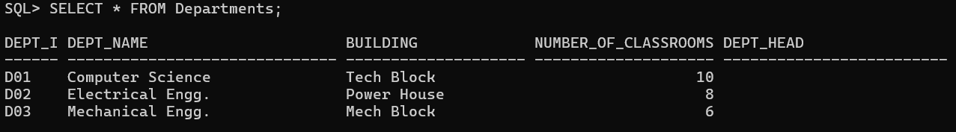

**Professors:**

|  |  |  |  |
| --- | --- | --- | --- |
| **Prof_ID** | **Prof_Name** | **Dept_ID** | **Experience_Years** |
| P1001 | Dr. Meera Nair | D01 | 12 |
| P1002 | Dr. Arjun Rao | D02 | 9 |
| P1003 | Dr. Kavita Singh | D01 | 7 |
| P1004 | Dr. Raj Malhotra | D03 | 15 |

**CODE:**

INSERT INTO Professors VALUES('P1001', 'Dr. Meera Nair','D01',12);

INSERT INTO Professors VALUES('P1002', 'Dr. Arjun Rao','D02',9);

INSERT INTO Professors VALUES('P1003', 'Dr. Kavita Singh','D01,7);

INSERT INTO Professors VALUES('P1004', 'Dr. Raj Malhotra','D03',15);

**OUTPUT:**

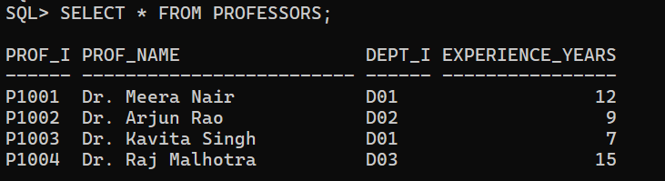

**Courses:**

|  |  |  |  |  |  |
| --- | --- | --- | --- | --- | --- |
| **Course_ID** | **Course_Name** | **Dept_ID** | **Prof_ID** | **Credits** | **Student_Count** |
| CSE101 | Data Structures | D01 | P1001 | 4 | 2 |
| CSE201 | Operating Systems | D01 | P1003 | 3 | 1 |
| EEE101 | Circuit Theory | D02 | P1002 | 4 | 1 |
| ME101 | Thermodynamics | D03 | P1004 | 3 | 1 |

**CODE:**

INSERT INTO Courses VALUES('CSE101','Data Structures','D01', 'P1001',4,2);

INSERT INTO Courses VALUES('CSE201','Operating Systems','D01', 'P1003',3,1);

INSERT INTO Courses VALUES('EEE101','Circuit Theory','D02', 'P1002',4,1);

INSERT INTO Courses VALUES('ME101','Thermodynamics','D03', 'P1004',3,1);

**OUTPUT:**

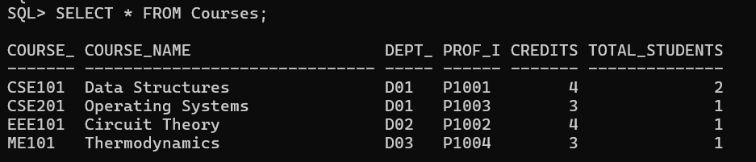

**Students:**

|  |  |  |  |
| --- | --- | --- | --- |
| **Student_ID** | **Student_Name** | **Dept_ID** | **DOB** |
| S0001 | Anjali Sharma | D01 | 2003-05-14 |
| S0002 | Ravi Kumar | D02 | 2002-11-20 |
| S0003 | Nisha Verma | D03 | 2003-02-02 |
| S0004 | Aman Sheikh | D01 | 2002-07-25 |

**CODE:**

INSERT INTO Students VALUES('S0001','Anjali Sharma','D01',TO_DATE('2003-05-14', 'YYYY-MM-DD'));

INSERT INTO Students VALUES('S0002',' Ravi Kumar','D02',TO_DATE('2002-11-20', 'YYYY-MM-DD'));

INSERT INTO Students VALUES('S0003',' Nisha Verma','D03',TO_DATE('2003-02-02', 'YYYY-MM-DD'));

INSERT INTO Students VALUES('S0004','Aman Sheikh','D01',TO_DATE('2002-07-25', 'YYYY-MM-DD'));

**OUTPUT:**

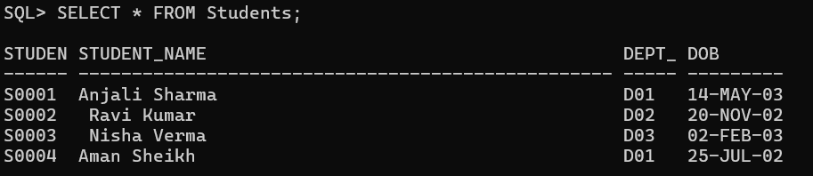

**Enrollments:**

|  |  |  |  |
| --- | --- | --- | --- |
| **Student_ID** | **Course_ID** | **Semester** | **Marks** |
| S0001 | CSE101 | Sem1 | 88.0 |
| S0001 | CSE201 | Sem2 | 76.5 |
| S0002 | EEE101 | Sem1 | 81.0 |
| S0003 | ME101 | Sem1 | 93.0 |
| S0004 | CSE101 | Sem1 | 68.5 |

**CODE:**

INSERT INTO Enrollments VALUES('S0001','CSE101','Sem1',88.0);

INSERT INTO Enrollments VALUES('S0001','CSE201','Sem2',76.5);

INSERT INTO Enrollments VALUES('S0002','EEE101','Sem1',81.0);

INSERT INTO Enrollments VALUES('S0003','ME101','Sem1',93.0);

INSERT INTO Enrollments VALUES('S0004','CSE101','Sem1',68.5);

**OUTPUT:**

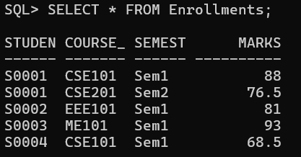

**2. Insert a new department: (‘D04’, ‘Civil Engg’, ‘Block C’, 5).**

**CODE:**

INSERT INTO Departments VALUES ('D04', 'Civil Engg', 'Block C', 5,NULL);

**OUTPUT:**

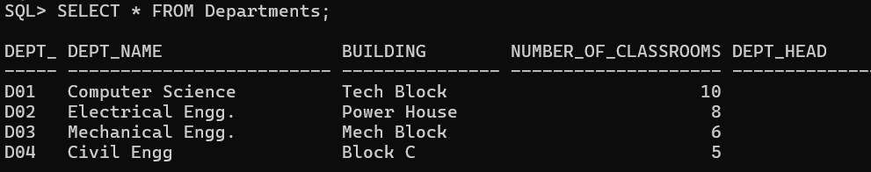

**3. Create a new table high_achievers containing students who scored more than 85 in any course.**

**CODE:**

CREATE TABLE high_achievers AS

SELECT Student_Name FROM Students

WHERE Student_ID IN

(SELECT Student_ID FROM Enrollments

WHERE marks>85);

**OUTPUT:**

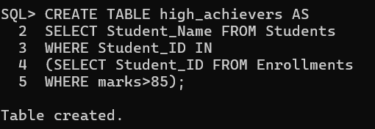

**4. Create a backup table Courses_Backup with all data from Courses and Professors_Backup with all the data from professors.**

**CODE:**

CREATE TABLE Courses_Backup AS SELECT * FROM Courses;

CREATE TABLE Professors_Backup AS SELECT * FROM Professors;

**OUTPUT:**

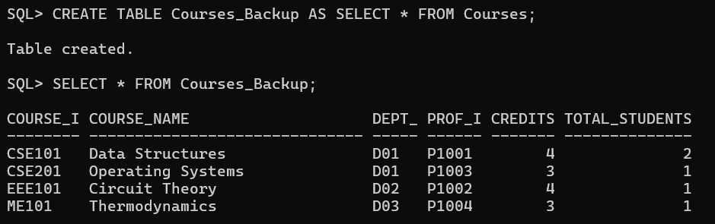

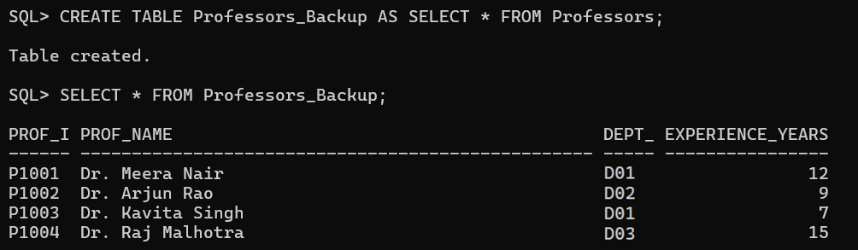

**5. Add a new course ‘CIV101’, ‘Structural Analysis’, under D04, taught by P1001, with 3 credits and 0 students.**

**CODE:**

INSERT INTO Courses VALUES('CIV101','Structural Analysis','D04', 'P1001',3,0);

**OUTPUT:**

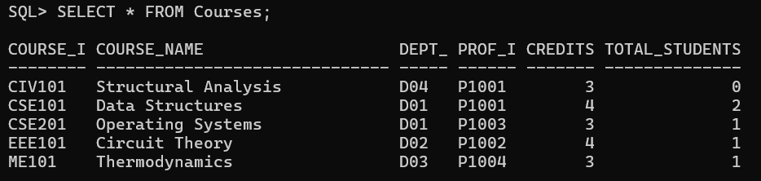

**6. Update professor of ‘CIV101’ to P1004 and savepoint SP1.**

**CODE:**

UPDATE Courses SET Prof_ID = 'P1004' WHERE Course_ID = 'CIV101';

SAVEPOINT SP1;

**OUTPUT:**

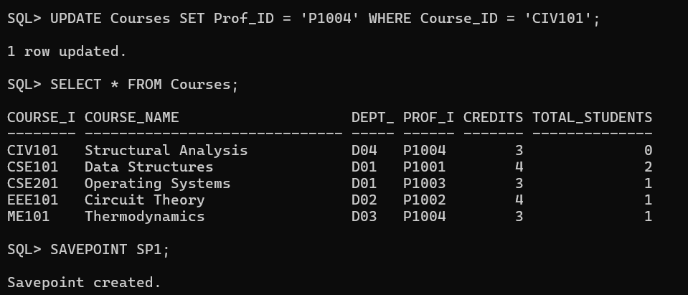

**7. Change credits of ‘CSE201’ to 4 and set savepoint SP2.**

**CODE:**

UPDATE Courses SET Credits = 4 WHERE Course_ID = 'CSE201';

SAVEPOINT SP2;

**OUTPUT:**

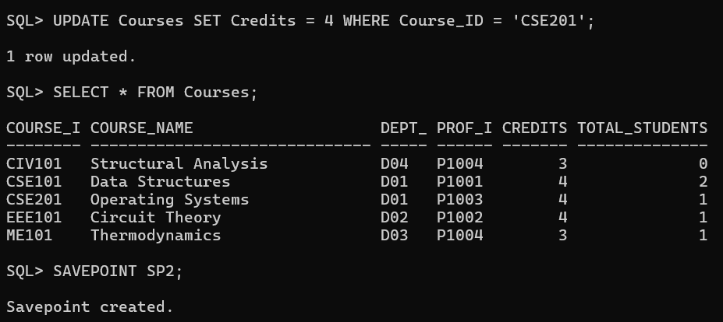

**8. Delete all courses from Courses_Backup that have less than 4 credits.**

**CODE:**

DELETE FROM Courses_Backup WHERE Credits < 4;

**OUTPUT:**

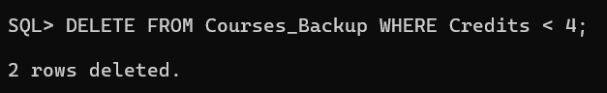

**9. Delete all professors from Professors_Backup with less than 10 years experience.**

**CODE:**

DELETE FROM Professors_Backup WHERE Experience_Years < 10;

**OUTPUT:**



**10. Rollback to SP1 and rename Courses_Backup to Course_Master.**

**CODE:**

ROLLBACK TO SP1;

ALTER TABLE Course_Backup RENAME TO Course_Master;

**OUTPUT:**

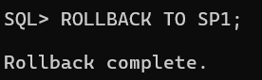

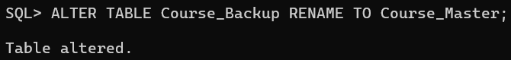

**4.2 Data Retrieval (SELECT)**

**1. List all department names.**

**CODE:**

SELECT Dept_Name FROM Departments;

**OUTPUT:**

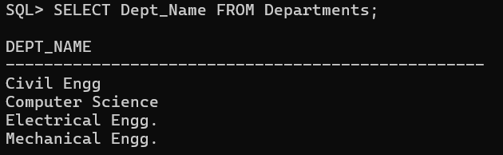

**2. Display all data from the Professors table.**

**CODE:**

SELECT * FROM Professors;

**OUTPUT:**



**3. List student names and DOBs.**

**CODE:**

SELECT Student_Name, DOB FROM Students;

**OUTPUT:**

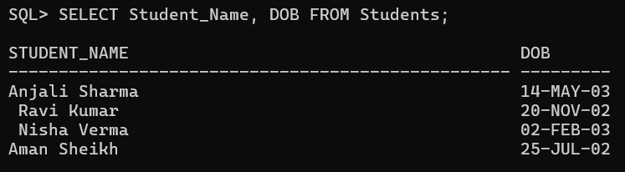

**4. List course names and credits.**

**CODE:**

SELECT Course_Name, Credits FROM Courses;

**OUTPUT:**

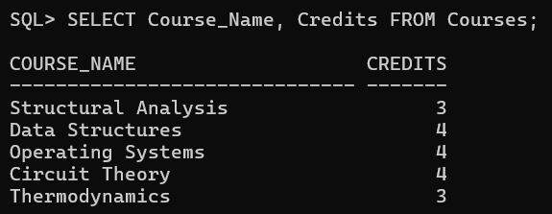

**5. Get courses offered by the ‘Computer Science’ department.**

**CODE:**

SELECT * FROM Courses WHERE Dept_ID IN

(SELECT Dept_ID FROM Departments WHERE Dept_Name = 'Computer Science');

**OUTPUT:**

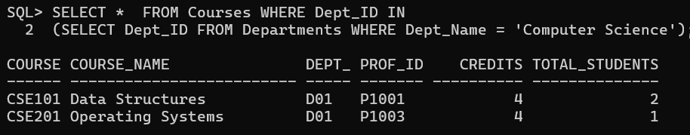

**6. List professors whose name starts with ‘Dr’.**

**CODE:**

SELECT * FROM Professors WHERE Prof_Name LIKE 'Dr%';

**OUTPUT:**

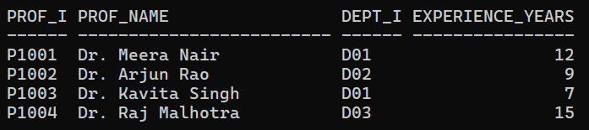

**7. List courses with credits more than 3.**

**CODE:**

SELECT * FROM Courses WHERE Credits > 3;

**OUTPUT:**

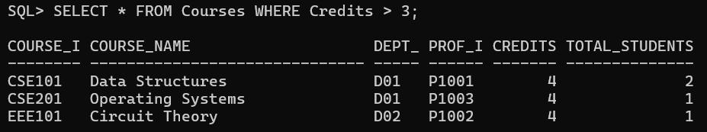

**8. Display all courses with “Theory” in their name.**

**CODE:**

SELECT * FROM Courses WHERE Course_Name LIKE '%Theory%';

**OUTPUT:**

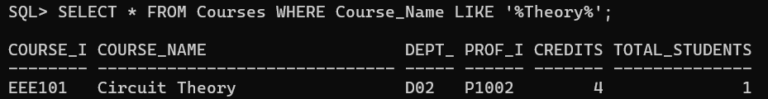

**9. List students born after Jan 1, 2003.**

**CODE:**

SELECT * FROM Students WHERE DOB > TO_DATE('01-01-2003', 'DD-MM-YYYY');

**OUTPUT:**

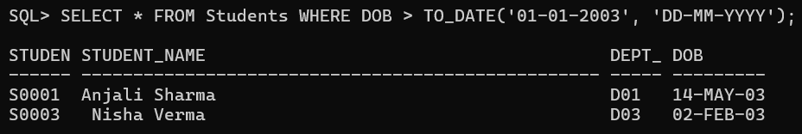

**10. Find all professors with 10+ years experience.**

**CODE:**

SELECT * FROM Professors WHERE Experience_Years >= 10;

**OUTPUT:**

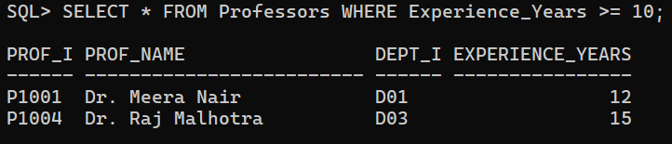

**11. List all courses with more than 1 student.**

**CODE:**

SELECT * FROM Courses WHERE Total_Students > 1;

**OUTPUT:**

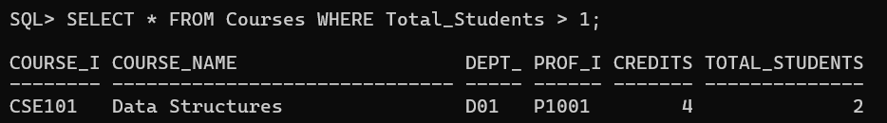

**12. Display all distinct semesters from Enrollments.**

**CODE:**

SELECT DISTINCT Semester FROM Enrollments;

**OUTPUT:**

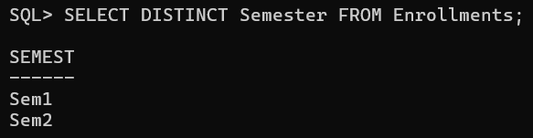

**13. Show information of students with ID S0001, S0002.**

**CODE:**

SELECT * FROM Students WHERE Student_ID IN ('S0001', 'S0002');

**OUTPUT:**

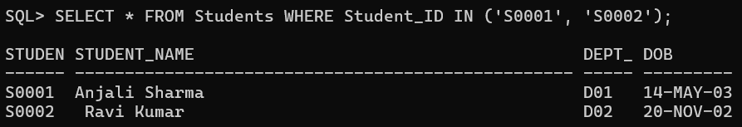

**14. Show all courses not in the ‘Mechanical Engg’ department.**

**CODE:**

SELECT * FROM Courses WHERE Dept_ID NOT IN

(SELECT Dept_ID FROM Departments WHERE Dept_Name = 'Mechanical Engg.');

**OUTPUT:**

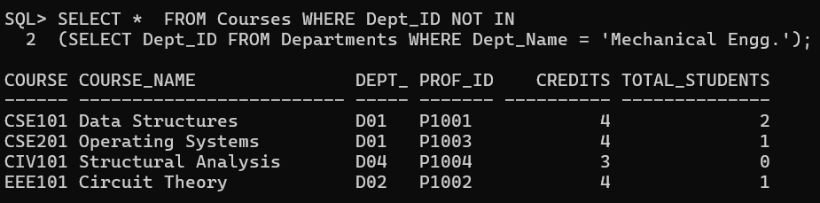

**4.3 SQL Functions**

**1.Use numeric functions like ROUND, MOD, POWER on dummy values.**

**CODE:**

SELECT ROUND(126.2587447, 2) FROM dual;

SELECT MOD(10, 3) FROM dual;

SELECT POWER(2, 2) FROM dual;

**OUTPUT:**

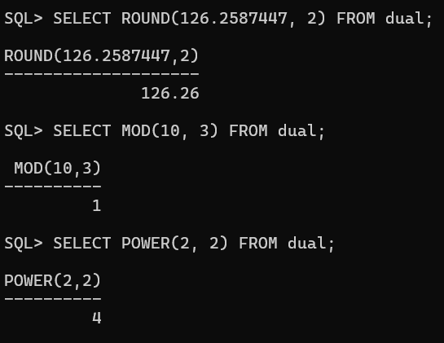

**2. Use string functions like LENGTH, SUBSTR, INSTR, UPPER, LOWER on names in Professors and Students.**

**CODE:**

**For Professors:**

SELECT Prof_Name,

LENGTH(Prof_Name) AS Length,

SUBSTR(Prof_Name, 1, 5) AS Substr,

INSTR(Prof_Name, 'a') AS Pos,

UPPER(Prof_Name) AS Uppercase,

LOWER(Prof_Name) AS Lowercase

FROM Professors;

**For Students:**

SELECT Student_Name,

LENGTH(Student_Name) AS Length,

SUBSTR(Student_Name, 1, 5) AS Substr,

INSTR(Student_Name, 'a') AS Pos,

UPPER(Student_Name) AS Uppercase,

LOWER(Student_Name) AS Lowercase

FROM Students;

**OUTPUT:**

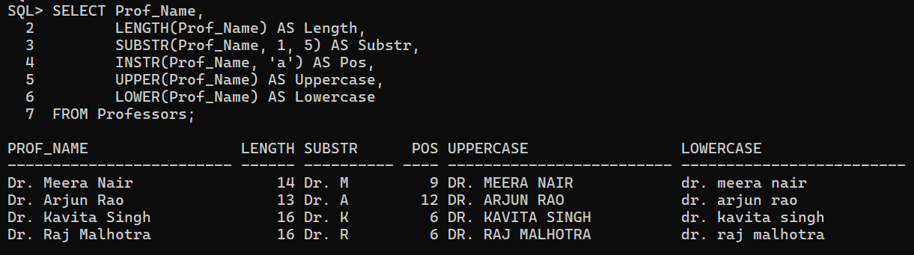

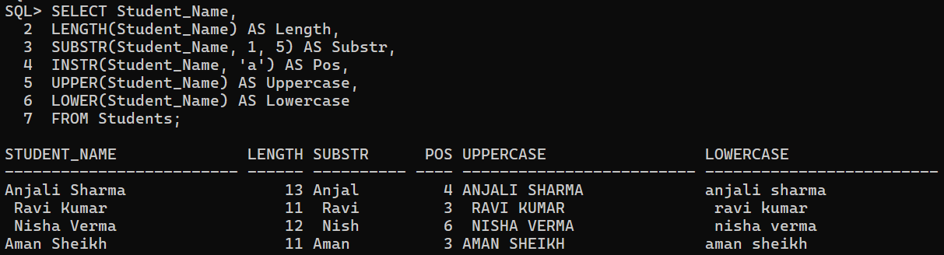

**3. Use conversion functions on DOB.**

**CODE:**

SELECT Student_ID, Student_Name, DOB,

TO_CHAR(DOB, 'DD-MM-YYYY') AS TO_CHAR,

TO_CHAR(DOB, 'Month') AS Month_Name

FROM Students;

SELECT TO_DATE('17-08-2004', 'DD-MM-YYYY') AS TO_DATE FROM DUAL;

**OUTPUT:**

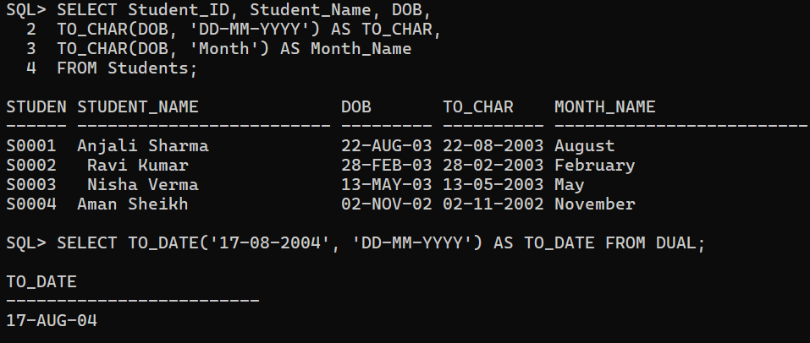

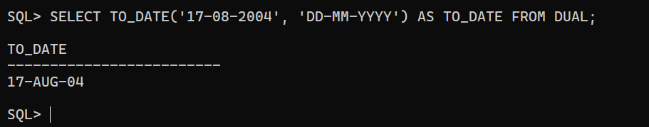

**4. Count total number of students.**

**CODE:**

SELECT COUNT(*) AS Total_Students FROM Students;

**OUTPUT:**

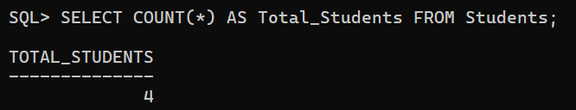

**5. Find max and min marks in Enrollments as max_marks, min_marks.**

**CODE:**

SELECT MAX(Marks) AS Max_Marks,

MIN(Marks) AS Min_Marks

FROM Enrollments;

**OUTPUT:**

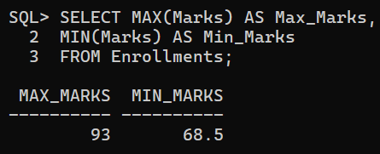

**6. Count number of students with marks over 75.**

**CODE:**

SELECT COUNT(*) AS Students_Above_75

FROM Enrollments

WHERE Marks > 75;

**OUTPUT:**

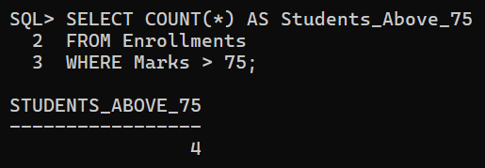

**4.4 Date Functions**

**1. List student names and their day of birth.**

**CODE:**

SELECT Student_Name,

TO_CHAR(DOB, 'Day') AS Day_Of_Birth

FROM Students;

**OUTPUT:**

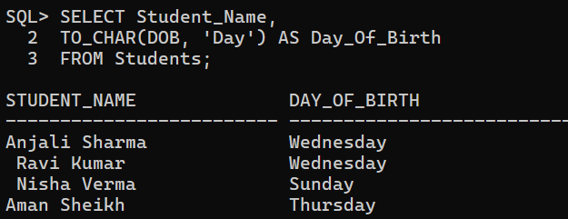

**2. Format DOBs in ‘DD-Month-YYYY’ format.**

**CODE:**

SELECT Student_Name,

TO_CHAR(DOB, 'DD-Month-YYYY') AS DOB

FROM Students;

**OUTPUT:**

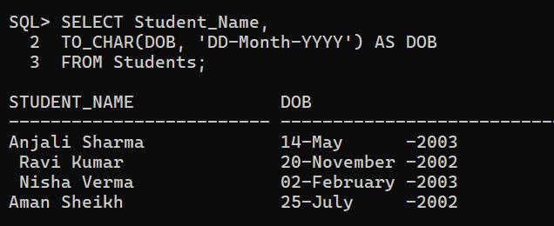

**3. Show DOBs in ‘DD-MM-YY’ format.**

**CODE:**

SELECT Student_Name,

TO_CHAR(DOB, 'DD-MM-YY') AS DOB

FROM Students;

**OUTPUT:**

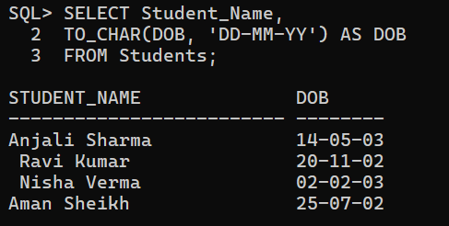

**4. Add 100 days to all DOBs.**

**CODE:**

UPDATE Students SET DOB = DOB + 100;

**OUTPUT:**

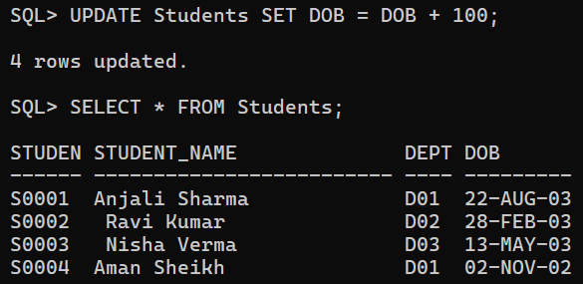

**5. List students born in May.**

**CODE:**

SELECT Student_Name, DOB

FROM Students

WHERE TO_CHAR(DOB, 'Mon') = 'May';

**OUTPUT:**

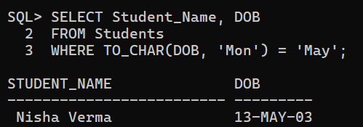

**6. List students born between 2002 and 2003.**

**CODE:**

SELECT Student_Name, DOB

FROM Students

WHERE TO_CHAR(DOB, 'yyyy') BETWEEN '2002' AND '2003';

**OUTPUT:**

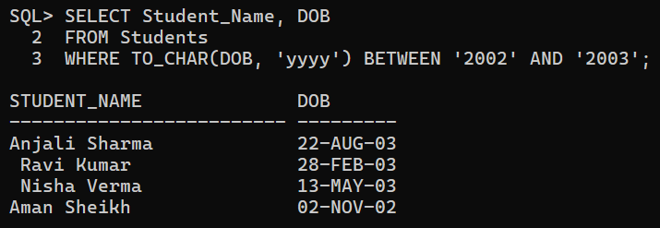

**4.5 Set Operators**

**Create Top_Courses table:**

CREATE TABLE Top_Courses (

Course_Name VARCHAR2(100),

Dept_Name VARCHAR2(50)

);

**Insert some course-department pairs.**

INSERT INTO Top_Courses VALUES ('Data Structures', 'Computer Science');

INSERT INTO Top_Courses VALUES ('Circuit Theory', 'Electrical Engg.');

INSERT INTO Top_Courses VALUES ('Thermodynamics', 'Mechanical Engg.');

INSERT INTO Top_Courses VALUES ('Artificial Intelligence', 'Computer Science');

INSERT INTO Top_Courses VALUES (' Concrete Technology', 'Civil Engg');

**OUTPUT:**

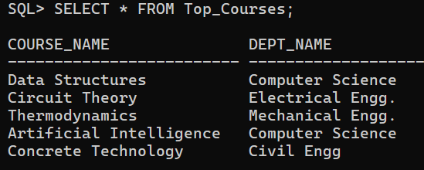

**1. Show unique course names from both Courses and Top_Courses.**

**CODE:**

SELECT Course_Name FROM Courses

UNION

SELECT Course_Name FROM Top_Courses;

**OUTPUT**

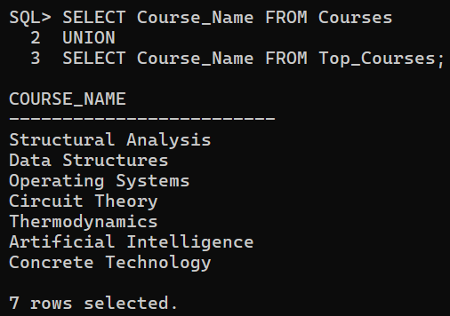

**2. Show common courses between Courses and Top_Courses.**

**CODE:**

SELECT Course_Name FROM Courses

INTERSECT

SELECT Course_Name FROM Top_Courses;

**OUTPUT**

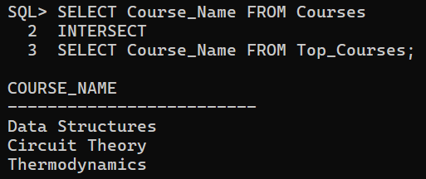

**3. Show top courses that are not in current courses.**

**CODE:**

SELECT Course_Name FROM Top_Courses

MINUS

SELECT Course_Name FROM Courses;

**OUTPUT**

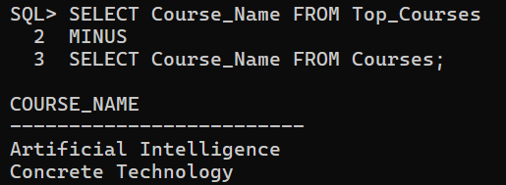

**4.Show union all of both.**

**CODE:**

SELECT Course_Name FROM Courses

UNION ALL

SELECT Course_Name FROM Top_Courses;

**OUTPUT:**

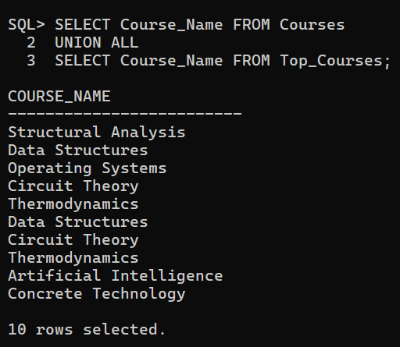

**4.6 Sorting**

**1. Sort professors by descending experience.**

**CODE:**

SELECT * FROM Professors

ORDER BY Experience_Years DESC;

**OUTPUT:**

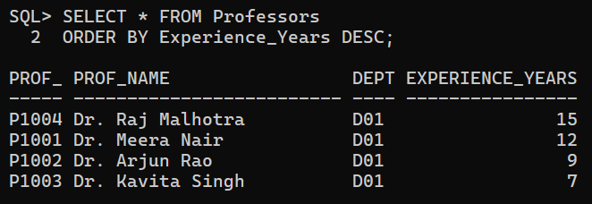

**4.7 Group By, Having**

**1. Number of students per department (only those >1).**

**CODE:**

SELECT Dept_Id, COUNT(Student_ID)

FROM Students

GROUP BY Dept_ID

HAVING COUNT(Student_ID) > 1;

**OUTPUT:**

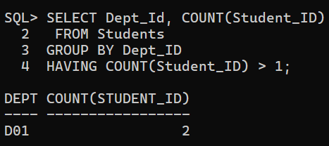

**2. Departments with avg classroom count >5.**

**CODE:**

SELECT Dept_Name, AVG(Number_of_Classrooms) AS AVG_CLASSROOMS

FROM Departments

GROUP BY Dept_Name

HAVING AVG(Number_of_Classrooms) > 5;

**OUTPUT:**

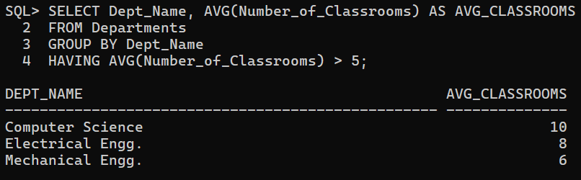

**3. Courses taught by professors with more than 1 course.**

**CODE:**

SELECT c.Course_Name, p.Prof_Name

FROM Courses c, Professors p

WHERE c.Prof_ID = p.Prof_ID

AND c.Prof_ID IN (

SELECT Prof_ID FROM Courses

GROUP BY Prof_ID

HAVING COUNT(Course_ID) > 1 );

**OUTPUT:**

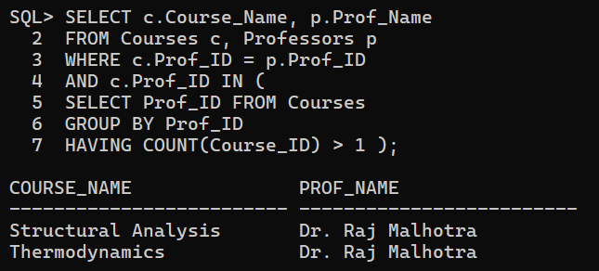

**4.8 Subqueries**

**1. Find names of students enrolled in any course.**

**CODE:**

SELECT Student_Name

FROM Students

WHERE Student_ID IN

(SELECT Student_ID

FROM enrollments);

**OUTPUT:**

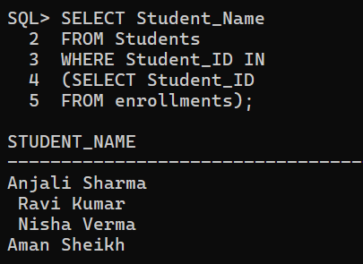

**2. Find department of student S0001.**

**CODE:**

SELECT Dept_ID, Dept_Name

FROM Departments

WHERE Dept_ID =

(SELECT Dept_ID

FROM Students

WHERE Student_ID = 'S0001');

**OUTPUT:**

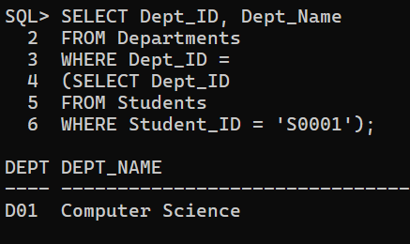

**3. Departments where student count > 1.**

**CODE:**

SELECT Dept_ID, Dept_Name

FROM Departments

WHERE Dept_ID IN

(SELECT Dept_ID

FROM Students

GROUP BY Dept_ID

HAVING COUNT(*) > 1 ) ;

**OUTPUT:**

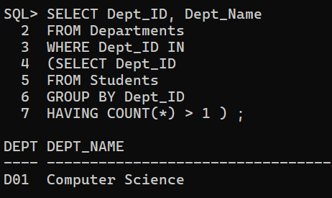

**4. List courses taught by professors with >10 years experience.**

**CODE:**

SELECT Course_ID, Course_Name

FROM Courses

WHERE Prof_ID IN

(SELECT Prof_ID

FROM Professors

WHERE Experience_Years > 10);

**OUTPUT:**

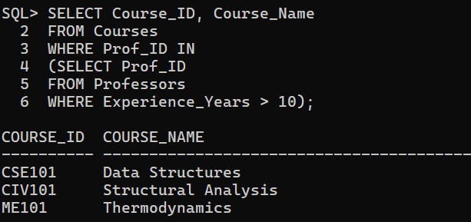

**5. List students in departments with at least 1 professor.**

**CODE:**

SELECT Student_Name

FROM Students

WHERE Dept_ID IN

(SELECT Dept_ID

FROM Professors

GROUP BY Dept_ID

HAVING COUNT(*) >= 1 );

**OUTPUT:**

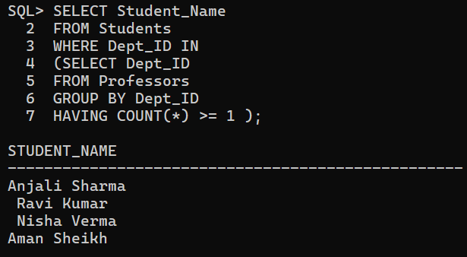

**6. Find the professors with exp less than the average experience of all the professors.**

**CODE:**

SELECT Prof_Name

FROM Professors

WHERE Experience_Years <

(SELECT AVG(Experience_Years)

FROM Professors );

**OUTPUT:**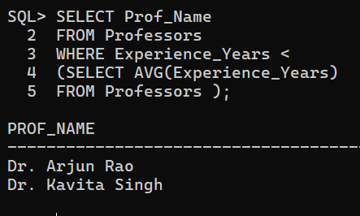

**4.9 NOT EXISTS**

**1. Departments where every professor has > 5 years experience.**

**CODE:**

SELECT D.Dept_Name, D.Dept_ID

FROM Departments D

WHERE NOT EXISTS

(SELECT P.Dept_ID

FROM Professors P

WHERE P.Dept_ID = D.Dept_ID

AND P. Experience_Years <=5 );

**OUTPUT:  
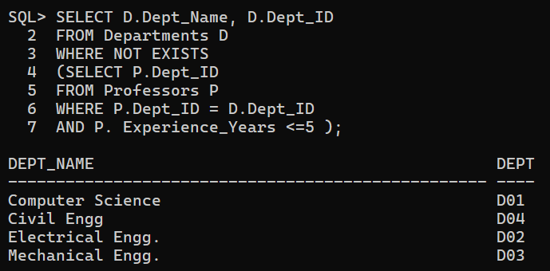**

**2. Departments with no students.**

**CODE:**

SELECT D.Dept_Name, D.Dept_ID

FROM Departments D

WHERE NOT EXISTS

(SELECT Dept_ID

FROM Students S

WHERE S.Dept_ID = D.Dept_ID );

**OUTPUT:**

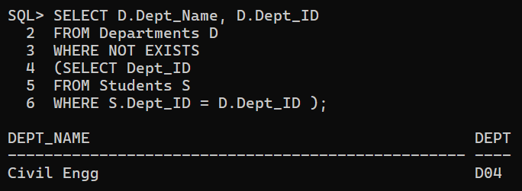

**4.10 Correlated Subqueries**

**1.** **Students with marks above average.**

**CODE:**

SELECT S.Student_Name, E.Course_ID, E.Marks

FROM Students S, Enrollments E

WHERE S.Student_ID = E.Student_ID

AND E.Marks > (

SELECT AVG(E2.Marks)

FROM Enrollments E2

WHERE E2.Course_ID = E.Course_ID );

**OUTPUT:**

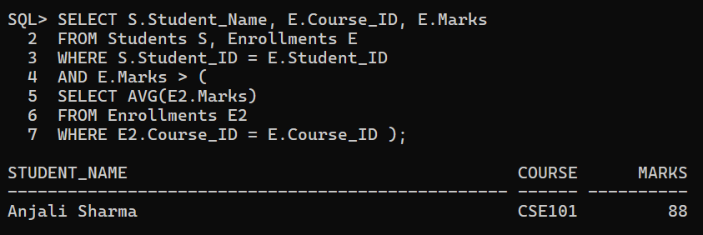

**2. Students with DOB later than any student from 'Electrical Engg'.**

**CODE:**

SELECT S.Student_Name, S.DOB

FROM Students S

WHERE EXISTS (

SELECT *

FROM Students S2

WHERE S2.Dept_ID = 'D02'

AND S.DOB > S2.DOB );

**OUTPUT:**

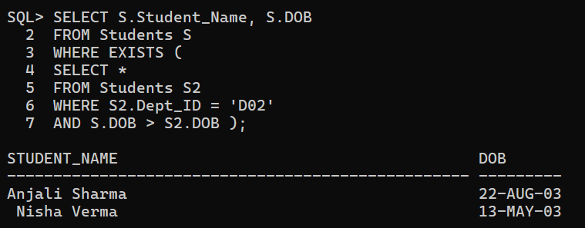

**4.11 JOINING Tables**

**1. List student names along with their department name.**

**CODE:**

SELECT S.Student_Name, D.Dept_Name

FROM Students S

INNER JOIN Departments D ON S.Dept_ID = D.Dept_ID;

**OUTPUT:**

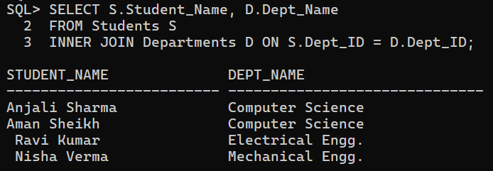

**2. Courses and number of students enrolled.**

**CODE:**

SELECT C.Course_ID, C.Course_Name, COUNT(E. Student_ID) AS COUNT

FROM Courses C

LEFT JOIN Enrollments E

ON C.Course_ID = E.Course_ID

GROUP BY C.Course_ID, C.Course_Name ;

**OUTPUT:**

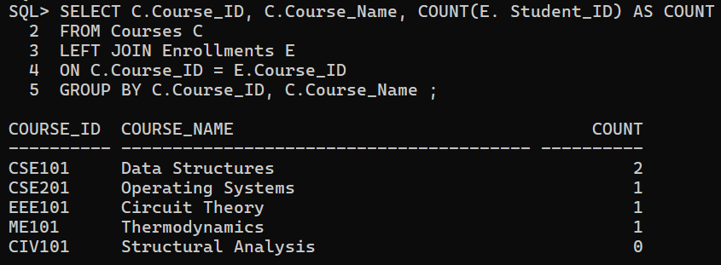

**3. List course name and professor name.**

**CODE:**

SELECT C.Course_ID, C.Course_Name, P.Prof_Name

FROM Courses C

INNER JOIN Professors P

ON C. Prof_ID = P. Prof_ID ;

**OUTPUT:**

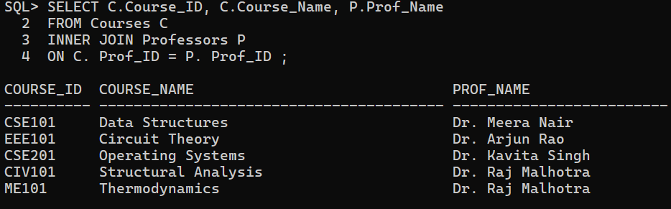

**4. Departments with more than one professor.**

**CODE:**

SELECT D.Dept_Name, COUNT(P.Prof_ID) AS Total_Professors

FROM Departments D

INNER JOIN Professors P

ON D.Dept_ID = P.Dept_ID

GROUP BY D.Dept_ID, D.Dept_Name

HAVING COUNT(P.Prof_ID) > 1;

**OUTPUT:**

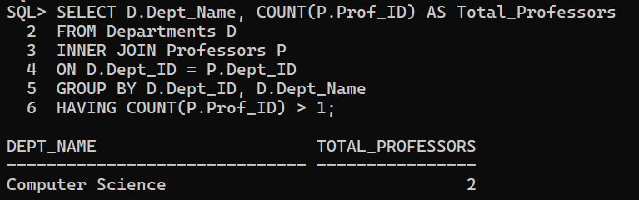

**5. List students enrolled in courses with more than 3 credits.**

**CODE:**

SELECT S.Student_ID, S.Student_Name, C.Course_ID, C.Credits

FROM Students S

INNER JOIN Enrollments E ON S.Student_ID = E.Student_ID

INNER JOIN Courses C ON E.Course_ID = C.Course_ID

WHERE C.Credits > 3;

**OUTPUT:**

